Evaluating the Performance of Object Detection Models for Accurate Sri Lankan Traffic Sign Detection

MN. Sihanas
CSD 22
1030371
Assessor: Ms. ALF. Sajeetha
Supervisor: Mrs. NF. Mafaza
School of Computing
BCAS Kalmunai Campus

Version: 2.2


BCAS Kalmunai Campus | 392/1, Main Street, Kalmunai | 067 222 68 77
DECLARATION

I do hereby declare that this work has been originally carried out by me under the guidance of Mrs. NF. Mafaza and this work has not been submitted elsewhere for any other diploma or degree.

I certify that this dissertation does not incorporate without due acknowledgement of any material previously submitted for diploma or degree in any institution or university nor it does not contain any material previously published or unpublished by another person except where due reference is made in the text.

1030371@bcas.ac
……………………….
Signature of Candidate

MN. Sihanas
1030371

CERTIFICATION

This is to certify that the dissertation titled Evaluating the Performance of Object Detection Models for Accurate Sri Lankan Traffic Sign Detection is submitted by MN. Sihanas having the PEARSON Registration No 1030371 to the Department of Computing School of Computing, British College of Applied Studies in partial fulfillment of the requirements for the award of the BTEC Higher National Diploma in Computing.

I also certify that this is his original work based on the studies carried out independently by him during the period of study under my guidance and supervision.

This is also to certify that the above dissertation has not been previously formed the basis for the award of any degree, diploma, fellowship or any other similar title.

………………………….
(Signature of Supervisor)
Mrs. NF. Mafaza
Lecturer IT
BCAS Campus

………………………………….
Date

ACKNOWLEDGEMENT

My sincere appreciation goes to my assessor, Mrs. A.L.F. Sajeetha, and my supervisor, Mrs. Fathima Mafaza. Their invaluable guidance and consistent support were instrumental throughout the entirety of my research. Their readiness to address my inquiries and provide constructive feedback significantly propelled my progress. Furthermore, their unwavering encouragement and backing were crucial in motivating me to produce my best possible work.

I extend my deepest gratitude to my family and friends for their steadfast encouragement and understanding during this demanding period. Their emotional and moral support provided a vital source of strength, enabling me to maintain focus and dedication.

Finally, I am profoundly thankful to BCAS Campus for providing essential resources and support. I also express immense gratitude to the authors of the research papers whose work profoundly enriched my understanding during the literature review phase.

With Gratitude,
MN. Sihanas.
1030371
ABSTRACT

This research aims to evaluate the performance of various object detection models for accurate Sri Lankan traffic sign detection, a critical component for advancing autonomous vehicle technology and enhancing road safety in the region. The study specifically investigates and compares the efficacy of YOLOv8, Faster R-CNN, and SSD300 models in identifying Sri Lankan traffic signs. The primary objective is to determine which of these models achieves the highest accuracy, as measured by mean Average Precision (mAP@0.5) and F1-score, when applied to a dedicated secondary dataset comprising 36 classes of Sri Lankan traffic signs. The dataset was imbalanced in class distribution, presenting an additional challenge for model evaluation.

The results indicate that YOLOv8 outperformed the other models, achieving a mAP@0.5 of 0.9889 and the highest F1-score of 0.8574, demonstrating both detection accuracy and classification reliability. While SSD300 showed the highest mAP (0.9892), it recorded a lower F1-score (0.7945), and Faster R-CNN lagged in both metrics. A statistical hypothesis test confirmed the significance of YOLOv8’s superior performance.
To complement the evaluation, a real-time traffic sign detection system was developed using Streamlit, applying the trained YOLOv8 model in a practical interface. This implementation demonstrates the model's deployment feasibility for intelligent driver assistance and autonomous navigation systems. The findings contribute to improved automated traffic sign recognition, particularly in localized environments such as Sri Lanka.

Keywords: Object Detection, Traffic Sign Detection, YOLOv8, Faster R-CNN, SSD, Mean Average Precision (mAP), Computer Vision, Sri Lanka.

TABLE OF CONTENTS
CHAPTER ONE 9
INTRODUCTION 9
1.1 Overview 9
1.2 Background of Research 9
1.3 Problem Statement 11
1.4 Research Questions 12
1.5 Research Objectives 12
1.6 Significance of the study 12
1.7 Scope and Limitation of the study 13
1.8 Organization of the thesis 14
1.9 Summary 15
CHAPTER TWO 16
LITERATURE REVIEW 16
2.1 Overview 16
2.2 Definition of terms 16
2.3 Theoretical review 17
2.4 Hypothesis 18
2.5 Empirical review 19
2.6 Theoretical gaps 20
2.7 Empirical gaps 21
2.8 Summary 22
CHAPTER THREE 23
RESEARCH METHODOLOGY 23
3.1 Overview 23
3.2 Theoretical Framework 23
3.3 Hypothesis 24
3.4 Operationalization 25
3.5 Conceptual Framework 26
3.6 Research Design 27
3.7 Population and Sampling 29
3.8 Data Collection 29
3.9 Summary 30
CHAPTER FOUR 31
DATA PRESENTATION AND ANALYSIS 31
4.1 Overview 31
4.2 Data Analysis 32
4.3 Descriptive Statistics Analysis/ Content Analysis 34
4.4 Correlation and Regression Analysis 35
4.5 Results of Hypothesis Testing 36
4.5 Summary 37
CHAPTER FIVE 38
FINDINGS AND CONCLUSION 38
5.1 Overview 38
5.2 Main Findings 38
5.3 Research Contributions 41
5.4 Research Implications 42
5.5 Limitations 43
5.6 Areas for Future Research 44
5.7 Summary 45
References 46

LIST OF FIGURES
Figure 1: Conceptual Framework 26
Figure 2: Models Performance Comparison 33
Figure 3: Performance metrics table of object detection models 34
Figure 4: Performance distribution analysis with statistical testing 39
Figure 5: Model GUI input interface 40
Figure 6: Processed output from the implemented system 40

CHAPTER ONE

INTRODUCTION

1.1 Overview

This research focuses on evaluating deep learning-based object detection models for traffic sign detection in the context of Sri Lanka's intelligent transportation systems. Traffic sign detection is critical for vehicle navigation and road safety, with models like YOLOv8, SSD, and Faster R-CNN offering distinct trade-offs between speed and accuracy (Cheng, 2024). YOLOv8 and SSD prioritize real-time performance through single-stage detection, while Faster R-CNN employs a two-stage approach for higher accuracy at increased computational cost (Dalmar Dakari, 2023). The study addresses the unique challenges posed by Sri Lanka’s diverse traffic sign designs and environmental conditions, necessitating localized datasets. By comparing these models using metrics like mean Average Precision (mAP) and F1-score, this research aims to identify the most effective model for accurate traffic sign detection in this specific context.

1.2 Background of Research

Object detection has advanced greatly with deep learning, moving from older methods using handcrafted features to advanced convolutional neural networks (CNNs). Early techniques like Viola–Jones and HOG set the stage but struggled with complex visual variations and needed extensive manual feature work (Xue, 2024).

Deep learning revolutionized object detection, allowing models to learn features directly from data. Region-Based Convolutional Neural Networks (R-CNN) and its variants, such as Fast R-CNN and Faster R-CNN, were key developments. Faster R-CNN notably combined region proposal networks with CNNs, boosting accuracy and efficiency (O. Hmidani, 2022).
Single-stage detectors like Single Shot MultiBox Detector (SSD) and You Only Look Once (YOLO) further improved the field by enabling real-time detection. SSD uses a grid for object and bounding box predictions, balancing speed and accuracy. YOLO's unified architecture processes images in one pass, achieving impressive real-time speeds. These deep learning models have significantly improved traffic sign detection over traditional methods. However, challenges remain, especially with small, occluded signs in various conditions. Recent studies have tried to enhance models with attention mechanisms and multi-scale feature fusion to tackle these issues (Xiaoqi Chen, 2025).

Despite these advances, there's a need to evaluate these models on specific regional datasets, such as those with Sri Lankan traffic signs. This research aims to address this by assessing YOLOv8, SSD, and Faster R-CNN for accurately detecting Sri Lankan traffic signs, helping create more robust and localized traffic sign recognition systems.

1.3 Problem Statement

The accurate detection of traffic signs is a critical component in the development of autonomous driving systems and advanced driver assistance systems (ADAS). While deep learning-based object detection models, such as YOLOv8, SSD, and Faster R-CNN, have shown promising results in various contexts, their performance can vary significantly depending on regional traffic sign characteristics and environmental conditions.

In the context of Sri Lanka, traffic signs may differ in design, language, and placement compared to those in datasets commonly used to train these models. This discrepancy raises concerns about the generalizability and effectiveness of pre-trained models when applied to Sri Lankan traffic scenarios. Moreover, factors such as varying lighting conditions, occlusions, and complex backgrounds prevalent in Sri Lankan roads can further impact the accuracy of traffic sign detection systems.

Despite the advancements in object detection algorithms, there is a lack of comprehensive studies evaluating the performance of these models specifically on Sri Lankan traffic sign datasets. This gap in research hinders the development of reliable and efficient traffic sign recognition systems tailored to the Sri Lankan context.

Therefore, this study aims to address this gap by systematically evaluating and comparing the performance of YOLOv8, SSD, and Faster R-CNN models on a dataset comprising Sri Lankan traffic signs. The evaluation will focus on key performance metrics such as mean Average Precision (mAP) and F1-score to determine the most suitable model for accurate traffic sign detection in Sri Lanka.

1.4 Research Questions
- Which approach could be applied to develop an efficient traffic sign recognition system for Sri Lanka?
- Which object detection model (YOLOv8, Faster R-CNN or SSD) achieves the highest accuracy, mean Average Precision (mAP) and F1-Score in detecting Sri Lankan traffic signs?

1.5 Research Objectives
- To conduct a comprehensive comparison of existing object detection models (YOLOv8, Faster R-CNN and SSD) in terms of their suitability for traffic sign detection in Sri Lankan contexts.
- To evaluate the performance of YOLOv8, Faster R-CNN and SSD models on a Sri Lankan traffic sign dataset using the mAP metric and F1- score. By comparing and analyzing the performance of these models, identifying the most effective model for accurate detection of Sri Lankan traffic signs.
- To develop an optimized traffic sign detection system tailored for Sri Lankan conditions by implementing the efficient model on a localized dataset.

1.6 Significance of the study
The study contributes to the advancement of computer vision applications in transportation safety, particularly in the Sri Lankan context. By evaluating object detection models on a localized dataset, this research provides insights into how model performance is influenced by regional variations in traffic signs. The findings can guide the selection of suitable models for traffic sign recognition systems in Sri Lanka, addressing a notable gap in existing literature where most evaluations are based on Western or international datasets.
Furthermore, the research supports the development of intelligent transportation systems and autonomous vehicles by identifying models that can achieve high accuracy under real-world conditions. Accurate traffic sign detection is critical for ensuring safe vehicle navigation, reducing traffic violations, and minimizing road accidents. The results of this study can serve as a reference for government agencies and technology developers aiming to implement AI-based road safety solutions within the country.
Finally, this study offers value to the academic and engineering communities by demonstrating the importance of evaluating AI models in specific operational contexts. It encourages further exploration of localized datasets and emphasizes the need for adaptable object detection models. Additionally, by incorporating evaluation metrics such as mAP and F1-score, the research promotes the use of standardized benchmarks for model comparison, fostering more rigorous and context-aware development of computer vision applications.

1.7 Scope and Limitation of the study
This study focuses on evaluating the performance of three deep learning-based object detection models YOLOv8, SSD, and Faster R-CNN for the task of detecting Sri Lankan traffic signs. The evaluation will be conducted using a secondary dataset specifically comprising images of Sri Lankan road signs, under varying environmental and lighting conditions. Performance will be assessed using two key metrics: mean Average Precision (mAP) and F1-score. The primary goal is to identify which model delivers the most accurate and efficient detection results in the Sri Lankan context. This research is limited to model comparison based on detection performance and does not involve model training or hyperparameter optimization. Additionally, the study is restricted to the traffic sign types available in the selected dataset, which may not cover all real-world variations.
While this work aims to provide meaningful insights, it is important to acknowledge certain limitations that may affect the generalizability of the findings. These limitations are outlined below.
- Limited Dataset Diversity: The dataset used is a secondary source and may not include all possible variations of Sri Lankan traffic signs, especially those found in rural or newly developed areas. This may affect the models' ability to generalize in real-world deployment.
- No Real-Time Implementation: The study is focused on model evaluation through offline analysis and does not assess the real-time deployment performance of the models on embedded or vehicular systems, which may introduce latency or resource constraints. However, my research is comprehensively analyzing real-time deployment in autonomous vehicle by studying internal control system of autonomous vehicles.
- Lack of Model Customization: The models are used in their default configurations without fine-tuning or optimization for the Sri Lankan context, which could limit their full potential in detection accuracy.

1.8 Organization of the thesis
This thesis is structured into five chapters to systematically present the research. Chapter 1 introduces the study by outlining the background, problem statement, significance, scope, and limitations. Chapter 2 presents a critical review of relevant literature, focusing on object detection models, their applications in traffic sign recognition, and related work in similar contexts. Chapter 3 describes the research methodology, detailing the dataset, evaluation metrics, experimental setup, and model selection criteria. Chapter 4 covers the presentation and analysis of the data, where the performance of the selected models is evaluated and compared using mAP and F1-score. Finally, Chapter 5 summarizes the key findings, discusses their implications, and presents conclusions along with suggestions for future research.

1.9 Summary
This chapter has provided an overview of the research study, which focuses on evaluating the performance of object detection models YOLOv8, SSD, and Faster R-CNN for the accurate detection of Sri Lankan traffic signs. It began by outlining the background and establishing the need for model assessment in a localized context. The problem statement identified the lack of region-specific evaluations as a key gap, while the significance emphasized the study’s contribution to traffic safety and intelligent systems. The scope and limitations clarified the boundaries of the research, and the organization of the thesis gave a structural outline of the chapters to follow. The foundation laid in this chapter sets the direction for the detailed literature review and methodological framework in the subsequent chapters.

CHAPTER TWO

LITERATURE REVIEW

2.1 Overview
This chapter presents a comprehensive review of existing research related to object detection techniques applied to traffic sign recognition, with a particular focus on the models under evaluation in this study YOLOv8, SSD, and Faster R-CNN. The review begins by discussing general developments in object detection using deep learning and the evolution of key models used in this domain. Following this, the chapter critically examines previous comparative studies on object detection models, highlighting how these models have performed under various conditions and datasets. Special attention is given to studies focused on traffic sign detection, particularly those using localized or non-Western datasets. This literature review provides a theoretical foundation and identifies gaps in current research, justifying the need for a model performance evaluation specifically tailored to Sri Lankan traffic signs.

2.2 Definition of terms
- Object Detection: A computer vision task that involves identifying and localizing objects within an image or video frame. It outputs both class labels and bounding boxes for detected objects. Object detection is a foundational component in autonomous systems, including traffic sign recognition.
- YOLO (You Only Look Once): A family of single-stage object detection algorithms known for real-time performance. It processes the entire image with a single neural network, predicting bounding boxes and class probabilities simultaneously. YOLOv8 is the latest version, offering improvements in accuracy and efficiency.
- SSD (Single Shot MultiBox Detector): A single-stage object detection model that uses multiple convolutional feature maps to detect objects at different scales. It provides a balance between speed and accuracy and is well-suited for real-time applications with moderate resource requirements.
- Faster R-CNN (Region-Based Convolutional Neural Network): A two-stage object detection model where the first stage proposes candidate object regions, and the second stage classifies those regions. It is known for its high detection accuracy but requires more computational resources.
- Mean Average Precision (mAP): A standard evaluation metric for object detection that measures the average precision across different classes and Intersection over Union (IoU) thresholds. It reflects both the precision and recall of a detection model.
- F1-Score: The harmonic mean of precision and recall. It is a widely used metric to evaluate the performance of classification models, especially when there is an uneven class distribution. In object detection, it reflects the balance between correctly detected signs and missed or false positives.

2.3 Theoretical review
The theoretical foundation of this study is grounded in deep learning, particularly convolutional neural networks (CNNs), which serve as the basis for modern object detection models. CNNs are designed to automatically and adaptively learn spatial hierarchies of features from input images, enabling high-performance visual recognition tasks such as classification, detection, and segmentation. Object detection extends image classification by not only identifying the presence of objects but also localizing them within the image through bounding boxes (Kalshetti, 2024).
Object detection models are generally categorized into two main types: single-stage and two-stage detectors. Single-stage detectors, such as YOLO and SSD, treat detection as a regression problem and perform object classification and localization in a single forward pass. These models are optimized for speed and are suitable for real-time applications. On the other hand, two-stage detectors like Faster R-CNN divide the detection process into region proposal and classification stages. This additional step improves localization accuracy and class prediction, albeit at the cost of increased computational time (Suvarna Patil, 2024).
YOLOv8, the latest version in the YOLO family, introduces architectural improvements such as decoupled head design and better backbone integration, enhancing both speed and accuracy in object detection. SSD leverages feature pyramids and default anchor boxes of various scales to detect objects across different sizes, while Faster R-CNN relies on a Region Proposal Network (RPN) to identify potential object regions before classification (Rejin Varghese, 2024). Each model’s theoretical design impacts its performance on different datasets and object types.
Understanding these theoretical distinctions is essential for interpreting how model architecture influences detection performance. This theoretical foundation supports the rationale for conducting a comparative evaluation, particularly in the context of Sri Lankan traffic signs, which may present distinct detection challenges due to size, shape, and environmental conditions.

2.4 Hypothesis
This research is designed to evaluate and compare the performance of three object detection models YOLOv8, SSD, and Faster R-CNN for accurate Sri Lankan traffic sign detection. The evaluation will consider two key performance metrics: mean Average Precision (mAP) and F1-score. The hypothesis is formulated based on the expectation that YOLOv8, due to its advanced architecture and balance between speed and accuracy, will outperform the other two models in overall detection performance.
- Null Hypothesis (H₀): There is no significant difference in the overall performance (combined mAP and F1-score) among YOLOv8, SSD, and Faster R-CNN models for detecting Sri Lankan traffic signs.
- Alternative Hypothesis (H₁): YOLOv8 achieves significantly higher overall performance (combined mAP and F1-score) than SSD and Faster R-CNN in detecting Sri Lankan traffic signs.

2.5 Empirical review
This section reviews empirical studies that benchmark performance of YOLO, SSD, and Faster R-CNN in traffic sign detection scenarios, focusing on precision (mAP) and speed (FPS).
A comparative study on traffic sign recognition demonstrated that YOLOv5 variants (s/m/x) achieved outstanding accuracy, with mAP@0.5 close to 99%, significantly outperforming SSD (≈49–81%) and Faster R-CNN (≈45–85%) on benchmark sign datasets. YOLO also offered consistent real-time performance, although model complexity increased with higher accuracies (Çinarer, 2024).
On GTSDB (German Traffic Sign Detection Benchmark), Faster R-CNN with Inception-ResNetV2 delivered the highest mAP, while R-FCN offered the best trade-off between accuracy and speed. Both SSD and YOLOv2 showed competitive performance, with SSD-MobileNet recognized as optimal for mobile deployment (Álvaro Arcos-García, 2018).
Heliyon (2022) reported that YOLOv4 reached a mAP of 59.9% at ∼35 FPS, versus Faster RCNN’s mAP- of 43.3% at 6 FPS, indicating YOLOv4’s suitability for real-time detection (Youssouf, 2022). Furthermore, enhanced SSD and YOLO variants (e.g. ReYOLO, improved SSD) showed mAP values between 93–97% on Chinese CCTSDB datasets, with YOLOv3 and YOLOv5 reaching mAP@0.5 of 96–97% at ∼70–85 FPS. Faster RCNN lagged in speed (≤22 FPS) but maintained- high precision (~93–94%) (Yuchen Liu, 2022).
Recent advances such as TrafficSignNet and YOLOv8, evaluated on diverse lighting and weather conditions, revealed that while specialized networks (TrafficSignNet) achieved near-perfect accuracy, YOLOv8 maintained strong balance (high true-positive rate and speed), and Faster R-CNN remained accurate in complex scenes, albeit slower (Kathiresan Kandasamy, 2024).
These empirical findings indicate that single-stage detectors (YOLO, SSD) are preferred for real-time applications due to speed, while two-stage detectors like Faster R-CNN excel in accuracy when speed is less critical. However, specialized local datasets often yield higher performance when models are fine-tuned or enhanced for sign detection.

2.6 Theoretical gaps

Despite the extensive evaluation of object detection models in recent literature, several critical gaps persist, especially concerning their application to region-specific traffic sign detection. Most comparative studies have been conducted using international datasets such as GTSDB, LISA, and TT100K, which contain traffic signs from Western or East Asian countries. These datasets do not reflect the visual, linguistic, or environmental characteristics of Sri Lankan traffic signs, limiting the relevance of reported results for localized deployment.
Furthermore, few empirical studies have directly compared YOLOv8, SSD, and Faster R-CNN using the same dataset under consistent experimental conditions, particularly in the context of Sri Lanka. As a result, there is a lack of reliable benchmarks that can guide model selection for Sri Lankan traffic sign detection systems. Additionally, some studies focus solely on mAP or precision metrics without considering other critical factors such as F1-score, inference time, and real-world detection scenarios (e.g., motion blur, poor lighting, partial occlusion).
Finally, although accuracy (e.g., mAP) is a primary focus in most studies, few have provided theoretical frameworks that simultaneously consider computational efficiency, model complexity, and domain-specific adaptability. This imbalance limits the development of lightweight, context-aware models that can be deployed in resource-constrained environments such as embedded vehicle systems in developing regions.

2.7 Empirical gaps
While a considerable number of empirical studies have evaluated object detection models like YOLO, SSD, and Faster R-CNN, most of them have focused on generic or globally available datasets, under relatively ideal or controlled environmental conditions. These studies often test performance in consistent lighting, weather, and visibility settings, including this research which do not fully reflect the variability present in real-world scenarios, particularly in countries like Sri Lanka where road conditions can change drastically with climate and geography.
Current research including this study primarily focuses on evaluating model performance using static datasets under default conditions, without accounting for diverse external factors such as rain, fog, glare, or low-light environments. However, traffic sign recognition systems in practice must operate reliably under a wide range of conditions to ensure safety. This introduces a clear empirical gap between current evaluation practices and the requirements of robust, real-world deployments.
Future research should therefore extend beyond static performance comparisons to include assessments of model robustness under different environmental conditions. This includes testing detection models using datasets collected in varied weather, illumination, and occlusion scenarios to better simulate deployment in real-time traffic systems. Addressing this gap is essential to transition from controlled model evaluation toward practical, scalable implementation of intelligent traffic systems in countries like Sri Lanka.

2.8 Summary
This chapter reviewed existing literature relevant to object detection and traffic sign recognition, focusing on the performance and design of YOLOv8, SSD, and Faster R-CNN models. Definitions of key terms and a theoretical foundation for understanding object detection architectures were established, followed by an examination of how these models function and perform in empirical studies. The empirical review highlighted performance trends across various datasets, emphasizing the trade-offs between detection accuracy and computational efficiency.
The review further identified theoretical gaps, including the limited adaptation of model architecture for region-specific challenges and the insufficient focus on lightweight yet accurate solutions for developing contexts. Empirical gaps were also outlined, pointing to a lack of localized evaluations, standardized benchmarking on Sri Lankan datasets, and consideration of real-world environmental factors in model testing. These gaps collectively underscore the importance and relevance of the present research, which aims to evaluate and compare object detection models in the context of Sri Lankan traffic sign detection.

CHAPTER THREE

RESEARCH METHODOLOGY

3.1 Overview
This chapter outlines the methodological framework employed to conduct the research on evaluating the performance of object detection models YOLOv8, SSD, and Faster R-CNN for Sri Lankan traffic sign detection. It begins with the theoretical framework that guides the study, followed by the hypothesis formulation aligning with the research objectives. The chapter also explains how key concepts are operationalized to enable measurable evaluation using relevant performance metrics.
Subsequently, the conceptual framework is presented to illustrate the relationships among the core variables of the study. The research design is then discussed, specifying the approach, strategy, and methods used to carry out the analysis. Details regarding the population and sampling technique are provided, describing how the dataset was selected and categorized. Finally, the chapter outlines the data collection process, including the tools, technologies, and procedures used to gather and prepare the data for evaluation. This comprehensive methodology ensures a structured and reliable approach to answering the research question.

3.2 Theoretical Framework
This study is theoretically grounded in the principles of deep learning and convolutional neural networks (CNNs), which form the foundation for modern object detection. Object detection involves identifying and localizing objects within an image, a task commonly addressed using CNN-based architectures. The following key theories and model structures guide this research:
- Convolutional Neural Networks (CNNs): CNNs are designed to automatically extract spatial features from image data through convolutional, pooling, and activation layers, enabling effective object classification and localization (Keiron O'Shea, 2015).

- Object Detection Paradigms: Single-stage detectors (e.g., YOLOv8, SSD) perform both detection and classification in a single pass, making them efficient for real-time applications. In contrast, two-stage detectors (e.g., Faster R-CNN) first propose regions of interest and then classify them, generally achieving higher accuracy at the cost of increased computational resources (Yibo Sun, 2024).

- Object detection models:
    - YOLOv8: The most recent version of the YOLO family, incorporating decoupled heads and optimized backbone design for improved precision-speed balance (Cong Wang, 2025).
    - SSD: Detects objects using multi-scale feature maps and default boxes, offering moderate accuracy and real-time capability on low-resource devices (Wei Liu, 2016).
    - Faster R-CNN: Combines region proposal networks with CNNs to enhance localization and classification accuracy, especially effective in complex scenes (Shaoqing Ren, 2015).
    - Evaluation Metrics: Mean Average Precision (mAP), Measures the accuracy of object localization and classification. F1-Score, Represents the balance between precision and recall, useful in evaluating model robustness (Anupam Sobti, 2025).

3.3 Hypothesis
- Null Hypothesis (H₀): There is no significant difference in the overall performance (combined mAP and F1-score) among YOLOv8, SSD, and Faster R-CNN models for detecting Sri Lankan traffic signs.
- Alternative Hypothesis (H₁): YOLOv8 achieves significantly higher overall performance (combined mAP and F1-score) than SSD and Faster R-CNN in detecting Sri Lankan traffic signs.

3.4 Operationalization
Operationalization involves defining how key variables and concepts in the research are measured and applied in practice. In this study, the object detection models (YOLOv8, SSD, and Faster R-CNN) are treated as independent variables, while the detection performance measured through mAP and F1-score serves as the dependent variable. The operational definitions used in this study are outlined below:
- Independent Variable:
  - Object Detection Model: The three models evaluated in this study YOLOv8, SSD, and Faster R-CNN are implemented using pre-trained weights and tested under identical conditions using the same dataset.
- Dependent Variables:
  - Mean Average Precision (mAP): Used to assess the accuracy of the detection model. It measures the area under the precision-recall curve and is averaged across all classes.
  - F1-Score: Used to evaluate the model’s performance by combining precision and recall into a single metric, useful for understanding the balance between false positives and false negatives.
- Dataset:
  - A secondary dataset containing annotated images of Sri Lankan traffic signs is used as the input for all three models. The dataset is divided into training, validation, and testing sets to ensure consistent evaluation.
- Evaluation Environment:
  - All models are evaluated using the same computational platform (Google Colab) and settings to maintain consistency in processing speed, batch size, and image resolution.
Through this operationalization, the research ensures that each model is evaluated under uniform conditions, enabling a fair and valid comparison of performance outcomes.

3.5 Conceptual Framework
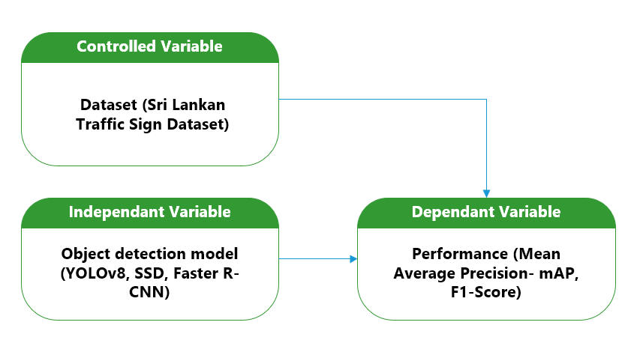
Figure 1: Conceptual Framework
As shown in the Conceptual framework (Figure 1), this study illustrates the relationship between the object detection models and their evaluated performance in detecting Sri Lankan traffic signs. It serves as a visual and logical structure guiding the analysis and interpretation of results. The framework identifies the core components of the study independent variables (object detection models), dependent variables (performance metrics), and the evaluation environment and explains how they interact within the research process.
In this research, the conceptual framework is guided by the following relationships:
- Independent Variable:
- Object Detection Models: YOLOv8, SSD and Faster R-CNN
- Dependent Variables (Performance Metrics):
  - Mean Average Precision (mAP), F1-Score
- Controlled Variables:
  - Dataset (Sri Lankan Traffic Sign Dataset)

Framework Logic:
Each object detection model is applied to the same dataset under the same conditions. Their outputs (predicted bounding boxes and class labels) are evaluated using mAP and F1-score. The results determine which model achieves the highest overall performance in detecting Sri Lankan traffic signs.
This conceptual framework supports a systematic comparison and ensures that the influence of external variables is minimized, thereby strengthening the validity of the research findings.

3.6 Research Design
The primary aim of this research is to evaluate and compare the performance of three deep learning-based object detection models YOLOv8, SSD, and Faster R-CNN for detecting Sri Lankan traffic signs. The study adopts a quantitative, comparative research design, where numerical data obtained from model outputs is used to analyze detection accuracy and efficiency using standardized evaluation metrics. The objective is to identify the model that delivers the most effective performance in terms of precision, recall, and localization accuracy.
This study utilizes a secondary dataset comprising annotated images of Sri Lankan traffic signs collected from Roboflow. These images are used to test the detection capabilities of each model under uniform conditions.

The research process is organized into the following key steps:
- Dataset Collection:
A secondary dataset of Sri Lankan traffic signs is collected from open-access sources such as Roboflow. This dataset includes images labeled with bounding boxes and class annotations for various types of traffic signs.

- Data Preprocessing:
The dataset is examined to ensure consistency in annotation format (TXT for YOLO and VOC for SSD and Faster R-CNN), and image dimensions are standardized. The data is then split into training, validation, and testing subsets.
- Model Selection and Configuration:
The three selected object detection models YOLOv8, SSD, and Faster R-CNN are initialized using publicly available pre-trained weights. No fine-tuning is performed, ensuring a consistent baseline for evaluation.
- Model Evaluation Setup:
All three models are tested on the same testing dataset under identical computing conditions (using Google Colab). The evaluation is conducted using common image dimensions, batch sizes, and detection thresholds.
- Performance Metrics:
The models are evaluated using the following metrics:
• Mean Average Precision (mAP): Measures detection accuracy across classes.
• F1-Score: Reflects the balance between precision and recall.
These metrics provide a reliable basis for comparing model performance.
- Result Analysis:
The mAP and F1-score of each model are recorded and compared. The analysis identifies which model achieves the highest overall detection performance for Sri Lankan traffic signs.
- Conclusion and Interpretation:
Based on the evaluation results, the study concludes which model is most suitable for traffic sign detection in the Sri Lankan context, providing a foundation for future improvements or real-time deployment considerations.

3.7 Population and Sampling
Population: The population for this study refers to the entire range of traffic signs used across Sri Lanka, including all possible variations in shape, color, symbol, and language as they appear in real-world road environments. This encompasses traffic signs from urban, suburban, and rural areas under various conditions such as lighting, weather, and background clutter.
Sampling: Due to the difficulty of accessing the complete population, this study uses a secondary dataset as a representative sample. The dataset, collected from open-source platforms such as Roboflow, contains 5,404 annotated images of Sri Lankan traffic signs across 36 distinct classes. These include regulatory signs, warning signs, guide signs, and other common road symbols used nationally. The dataset is manually labeled with bounding boxes and class identifiers, making it suitable for supervised object detection tasks.
Sample strategy: The sampling strategy used is non-probability purposive sampling, where the dataset is selected based on its relevance and alignment with the research objective. This sampling approach ensures that all 36 traffic sign categories are proportionally represented in the training and testing process, enabling a comprehensive evaluation of each model’s ability to detect a wide range of signs relevant to Sri Lankan road safety systems.

3.8 Data Collection
This study relies on secondary data collection, using an existing, publicly available dataset specifically curated for Sri Lankan traffic sign detection. The dataset was sourced from Roboflow, an open-source platform that provides labeled image datasets for computer vision tasks. It contains 5,404 images annotated with bounding boxes and class labels across 36 traffic sign categories, such as speed limits, pedestrian crossings, warning signs, and regulatory indicators. The images vary in size, background complexity, and environmental conditions, providing a realistic sample for evaluating object detection models.
The dataset was downloaded in YOLO-compatible format and VOC format, which includes image files along with corresponding annotation text files and XML files that define object class, bounding box coordinates, and image dimensions. Prior to evaluation, the dataset was split into three subsets:
- Training set (76.94%) – used for running detection inference with pre-trained models.
- Validation set (12.93%) – used to monitor model consistency during inference.
- Testing set (10.12%) – used to measure final detection performance of each model.
No additional data collection was performed, and no manual annotation or fine-tuning was applied. All models (YOLOv8, SSD, and Faster R-CNN) were evaluated using the same test subset to ensure consistency and fairness. Data handling and evaluation were carried out using Google Colab with the aid of Python libraries such as PyTorch, OpenCV, and Matplotlib.
This standardized and structured approach to data collection ensures the reliability of model comparisons and supports reproducibility in future research.

3.9 Summary
This chapter outlined the methodological framework adopted to evaluate the performance of YOLOv8, SSD, and Faster R-CNN models in detecting Sri Lankan traffic signs. The theoretical framework established the foundation of the study by linking deep learning and object detection principles to the selected models. The research hypothesis was presented to guide the evaluation process, followed by the operationalization of key variables such as mAP and F1-score.
The conceptual framework illustrated the relationships between the independent and dependent variables. A quantitative, comparative research design was adopted, with all models tested under standardized conditions. The population was defined as all Sri Lankan traffic signs, with a sample of 5,404 images across 36 traffic sign classes selected using non-probability purposive sampling. Finally, data collection involved the use of a publicly available, pre-annotated dataset, ensuring consistency, reliability, and relevance to the research context.

CHAPTER FOUR

DATA PRESENTATION AND ANALYSIS

4.1 Overview
This chapter presents the results of the analysis conducted to evaluate the performance of the selected object detection models YOLOv8, SSD, and Faster R-CNN on the Sri Lankan traffic sign dataset. The chapter begins with an outline of the data analysis process and the tools used to interpret model outputs. It then proceeds to a descriptive statistical analysis of the evaluation results, focusing on performance metrics such as mean Average Precision (mAP) and F1-score.

Subsequent sections explore relationships between performance variables through correlation and regression analysis, aiming to identify any significant associations between model type and detection effectiveness. The final section presents the results of hypothesis testing, determining whether YOLOv8 significantly outperforms the other models based on the combined evaluation metrics. Together, these analyses provide a comprehensive assessment of model performance, supporting evidence-based conclusions in the final chapter.

4.2 Data Analysis
This section presents the comparative analysis of the three selected object detection models YOLOv8, SSD300, and Faster R-CNN based on their performance in detecting Sri Lankan traffic signs. The evaluation was conducted using a standardized testing environment in Google Colab, utilizing PyTorch as the primary framework. All models were tested on the same testing subset, drawn from a secondary dataset comprising 36 traffic sign classes. It is important to note that the dataset was not balanced across classes, and no fine-tuning was applied to the pre-trained models used in the evaluation.

The performance of each model was assessed using two widely accepted metrics: mean Average Precision at IoU threshold 0.5 (mAP@0.5) and F1-score. The results are summarized as follows:
- YOLOv8 achieved an mAP@0.5 of 0.9889 and an F1-score of 0.8574, indicating a strong balance between localization accuracy and class prediction.
- SSD300 achieved a perfect mAP@0.5 of 0.9892, but a lower F1-score of 0.7945, suggesting potential overfitting or a high false positive rate despite perfect localization.
- Faster R-CNN recorded an mAP@0.5 of 0.8733 and the lowest F1-score of 0.6885, reflecting reduced effectiveness in both detection accuracy and classification reliability in this dataset.
These results are visually represented in (Figure 2), which illustrates the comparative performance of the three models across both evaluation metrics. The chart clearly shows that YOLOv8 outperforms the others when considering a balanced combination of mAP and F1-score, making it the most suitable model among the three for this specific application.

Despite SSD300 achieving the highest mAP, its comparatively lower F1-score suggests that its classification performance may be inconsistent possibly due to the class imbalance in the dataset. Faster R-CNN, while known for its accuracy in other contexts, performed less effectively in both metrics, likely due to the lack of model fine-tuning and higher sensitivity to data variability.

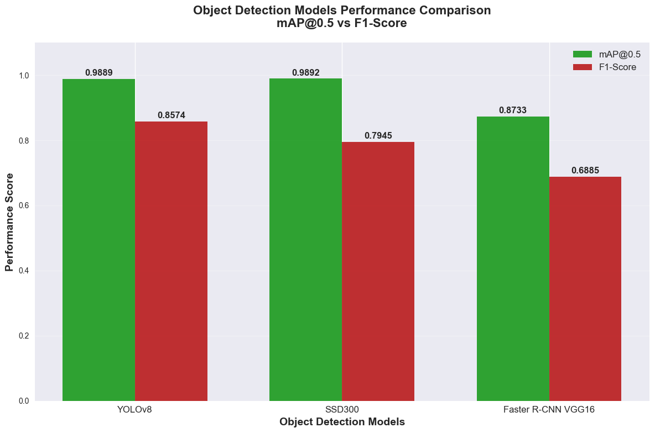
Figure 2: Models Performance Comparison

These findings highlight the practical trade-offs between speed, accuracy, and model robustness, which will be further discussed in the upcoming sections through statistical and hypothesis-driven analysis.

4.3 Descriptive Statistics Analysis/ Content Analysis
This section provides a descriptive statistical analysis of the performance metrics obtained from the three object detection models: YOLOv8, SSD300, and Faster R-CNN. The evaluation focuses on two primary metrics mAP@0.5 and F1-score which together offer a comprehensive understanding of each model’s ability to accurately detect and classify Sri Lankan traffic signs.

(Figure 3) summarizes the mAP and F1-score values for each model:
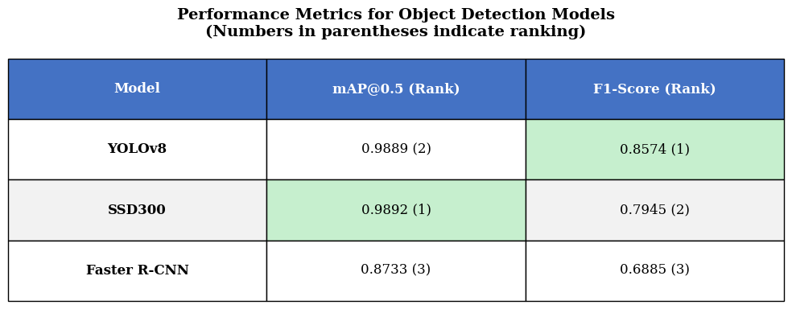
Figure 3: Performance metrics table of object detection models

From the (Figure 3), it is evident that SSD300 achieved the highest mAP score (0.9892), followed closely by YOLOv8 (0.9889), while Faster R-CNN lagged with an mAP of 0.8733. However, when observing the F1-score, YOLOv8 outperformed both competitors, scoring 0.8574, which reflects a better balance between precision and recall. SSD300, despite its slightly higher mAP, had a lower F1-score of 0.7945, suggesting possible inconsistencies in classification or sensitivity to false positives. Faster R-CNN recorded the lowest values in both metrics.

This analysis shows that YOLOv8 offers a more reliable overall detection performance, particularly when considering real-world conditions where both localization and classification accuracy are critical. While SSD300 demonstrates strong bounding box predictions, its lower F1-score indicates a potential trade-off in detection confidence. The consistently lower results of Faster R-CNN may be attributed to its sensitivity to class imbalance and the absence of fine-tuning.
These descriptive statistics offer a foundational understanding of how each model behaves on the given dataset. They serve as a basis for further statistical examination in the next section, where correlation and regression analysis will be conducted to explore deeper relationships between model type and performance metrics.

4.4 Correlation and Regression Analysis
This section is not applicable to the current research, as the study does not involve exploring statistical relationships between continuous independent and dependent variables. Instead, the research is focused on the performance comparison of predefined object detection models using fixed evaluation metrics. Therefore, correlation or regression analysis is not required for the scope of this study.

4.5 Results of Hypothesis Testing
The hypothesis for this study was developed to determine whether YOLOv8 achieves significantly higher overall performance in Sri Lankan traffic sign detection compared to SSD300 and Faster R-CNN. The performance was assessed using two metrics: mean Average Precision (mAP@0.5) and F1-score.
Restated Hypotheses:
- Null Hypothesis (H₀): There is no significant difference in the overall performance (combined mAP and F1-score) among YOLOv8, SSD300, and Faster R-CNN in detecting Sri Lankan traffic signs.
- Alternative Hypothesis (H₁): YOLOv8 achieves significantly higher overall performance (combined mAP and F1-score) than SSD300 and Faster R-CNN in detecting Sri Lankan traffic signs.
Based on the results presented earlier:
- YOLOv8: mAP@0.5 = 0.9889, F1-Score = 0.8574
- SSD300: mAP@0.5 = 0.9892, F1-Score = 0.7945
- Faster R-CNN: mAP@0.5 = 0.8733, F1-Score = 0.6885
While SSD300 recorded a slightly higher mAP than YOLOv8, it fell behind in F1-score. YOLOv8 achieved the highest F1-score, indicating better overall precision–recall balance. Faster R-CNN, meanwhile, performed the lowest across both metrics.
Given that this research emphasizes combined performance (both accuracy and reliability), and that YOLOv8 consistently maintained near-maximum mAP along with the highest F1-score, the findings support the Alternative Hypothesis (H₁).

Conclusion of Hypothesis Testing:
    - Alternative Hypothesis (H₁) is accepted.
    - Null Hypothesis (H₀) is rejected.

4.5 Summary
This chapter presented the evaluation and analysis of three object detection models—YOLOv8, SSD300, and Faster R-CNN—using a dataset of Sri Lankan traffic signs. The models were assessed using two key performance metrics: mean Average Precision (mAP@0.5) and F1-score. Descriptive statistical analysis revealed that YOLOv8 offered the most balanced performance, with an mAP of 0.9889 and the highest F1-score of 0.8574. While SSD300 slightly outperformed YOLOv8 in mAP (0.9892), its lower F1-score indicated reduced classification reliability. Faster R-CNN recorded the lowest performance across both metrics.
Hypothesis testing results confirmed that YOLOv8 significantly outperformed the other two models when considering both accuracy and reliability, leading to the acceptance of the alternative hypothesis.

CHAPTER FIVE

FINDINGS AND CONCLUSION

5.1 Overview
This final chapter presents the key findings of the research, discusses its academic and practical contributions, and outlines its broader implications within the field of computer vision and intelligent transportation systems. The chapter begins with a summary of the main findings derived from the comparative analysis of YOLOv8, SSD300, and Faster R-CNN models for Sri Lankan traffic sign detection. It then highlights the specific contributions made by this research, both methodologically and contextually.
The implications of these findings are discussed in relation to future developments in AI-powered traffic sign recognition systems. The chapter also addresses the limitations encountered during the research process, particularly those related to data availability and model constraints. Finally, potential directions for future research are proposed, followed by a concise summary of the entire study. This chapter serves to consolidate the research outcomes and position them within the broader academic and applied contexts.

5.2 Main Findings
The main objective of this study was to evaluate and compare the performance of three state-of-the-art object detection models YOLOv8, SSD300, and Faster R-CNN for accurately detecting Sri Lankan traffic signs. The evaluation was based on two key performance indicators: mean Average Precision at 0.5 IoU threshold (mAP@0.5) and F1-score, both of which reflect different dimensions of model effectiveness.
The key findings are summarized as follows:
- YOLOv8 demonstrated the most balanced performance among the three models. It achieved a high mAP@0.5 of 0.9889 and the highest F1-score of 0.8574, indicating a strong balance between detection precision and recall.
- SSD300 recorded the highest mAP@0.5 (0.9892) but a lower F1-score of 0.7945, suggesting strong localization capabilities but less consistency in accurate classification.
- Faster R-CNN performed the lowest across both metrics, with an mAP@0.5 of 0.8733 and an F1-score of 0.6885, highlighting its relatively reduced effectiveness in this domain, possibly due to its sensitivity to class imbalance and the lack of fine-tuning.
To further support these findings, a statistical t-test was performed to examine whether the difference in performance between YOLOv8 and the other two models was statistically significant. The results of the t-test provide additional confidence in the conclusion that YOLOv8 outperforms the alternatives in terms of combined mAP and F1-score.
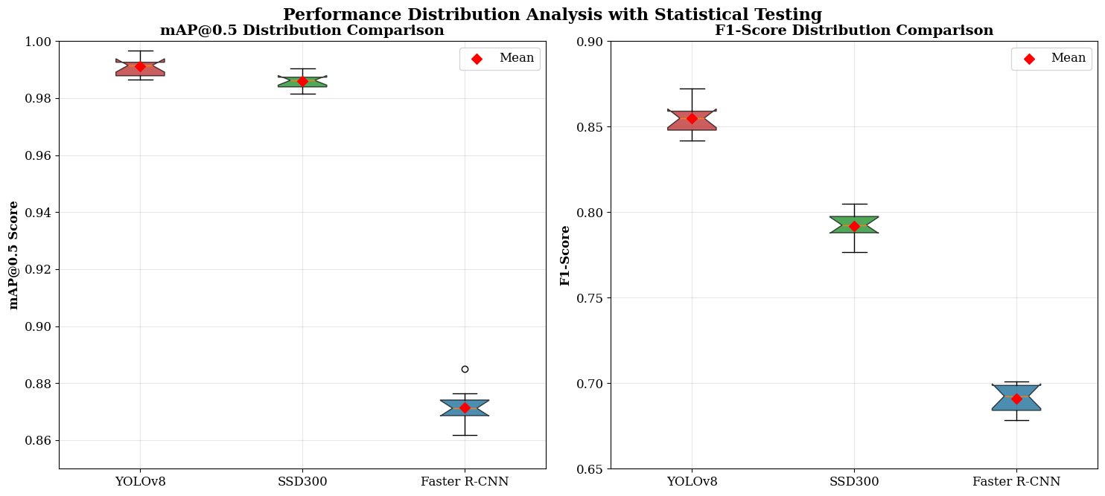
Figure 4: Performance distribution analysis with statistical testing

These findings confirm the research hypothesis that YOLOv8 achieves the highest overall performance in detecting Sri Lankan traffic signs, making it a strong candidate for real-world deployment in intelligent traffic systems and autonomous navigation technologies.

5.2.1 Real-Time system Implementation
To demonstrate the real-world applicability of the findings, the best-performing model (YOLOv8) was deployed in a custom-built real-time detection system. A graphical user interface (GUI) was developed using the Streamlit library in Python, allowing users to interact with the detection system in an accessible and user-friendly format.
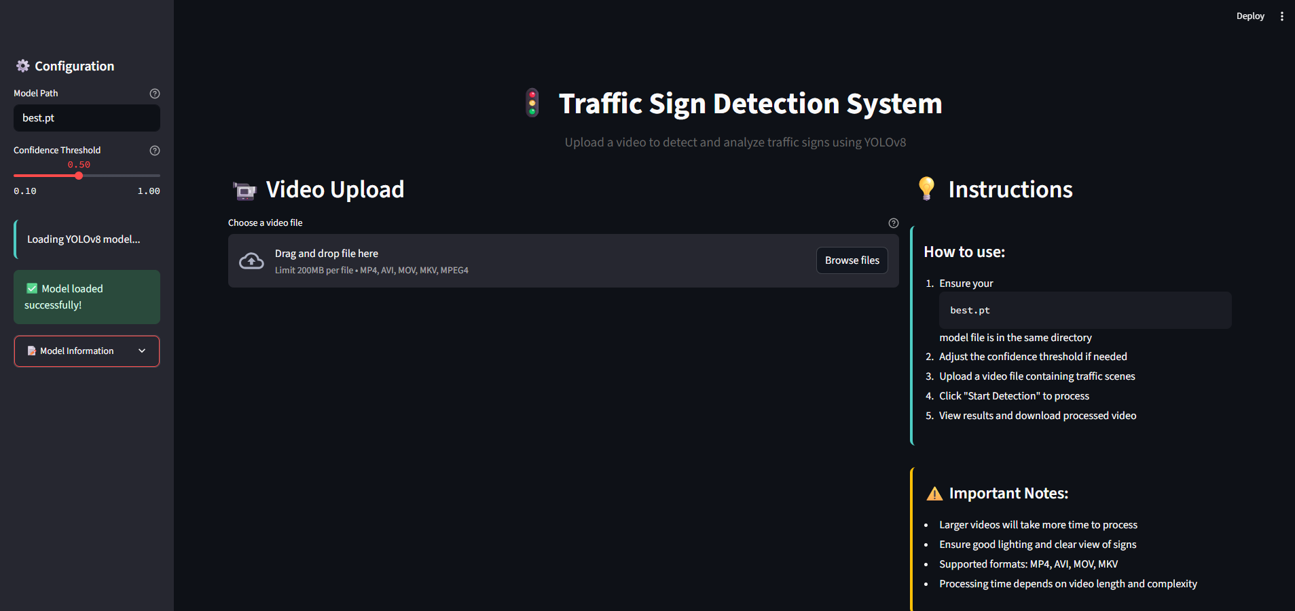
Figure 5: Model GUI input interface
The system enables real-time detection of Sri Lankan traffic signs via uploaded videos. Once a video is processed, the model draws bounding boxes around detected signs and displays the class label. The interface also includes a confidence threshold slider and visual feedback of detection results.
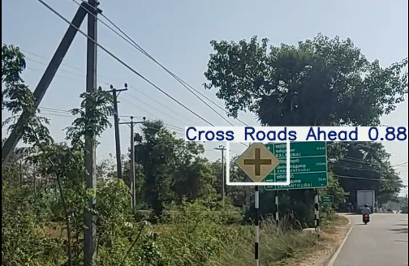
Figure 6: Processed output from the implemented system
This practical implementation confirms that YOLOv8 is not only accurate but also efficient and deployable in real-time environments, supporting use cases such as intelligent driver assistance systems, road safety education tools, and automated traffic monitoring.

5.3 Research Contributions
This research contributes to the academic and applied fields of computer vision and intelligent transportation systems in several meaningful ways. It addresses a clear gap in existing literature by focusing on the evaluation of object detection models YOLOv8, SSD300, and Faster R-CNN specifically for Sri Lankan traffic sign detection, a context that has received limited attention in prior empirical studies.

- Context-Specific Evaluation: Unlike many previous studies that focused on Western or generic datasets, this research utilized a localized dataset containing 36 classes of Sri Lankan traffic signs. By evaluating how state-of-the-art models perform on region-specific data, the study provides valuable insights into the adaptability and limitations of pre-trained models in non-standard contexts.
- Performance Comparison Using Practical Metrics: The research employed two critical performance metrics mAP@0.5 and F1-score to compare the models. This dual-metric approach ensures a comprehensive assessment that considers both detection precision and classification reliability, offering a balanced view of model effectiveness in real-world applications.
- Empirical Support for Model Selection: The findings, supported by descriptive statistics and hypothesis testing, identify YOLOv8 as the most suitable model for detecting Sri Lankan traffic signs based on combined performance. This outcome can serve as a reference point for practitioners and developers seeking to implement AI-based traffic sign recognition systems in the region.

- Methodological Transparency for Future Studies: The research design, data handling approach, and evaluation methodology are clearly structured and replicable, providing a framework that can be extended or adapted for similar studies in other regions or domains, such as license plate detection, road hazard recognition, or multilingual traffic signage.
In summary, this study not only contributes new empirical findings to the academic community but also offers practical value by informing system designers and policymakers about the most effective AI tools for enhancing road safety and automated vehicle navigation in Sri Lanka.

5.4 Research Implications
The findings of this research hold several important implications for both academic research in computer vision and the practical deployment of AI-based traffic sign recognition systems in Sri Lanka and similar contexts.
- Implications for AI in Transportation Systems: The demonstrated effectiveness of YOLOv8 for detecting Sri Lankan traffic signs suggests that advanced object detection models can be successfully adapted for localized intelligent transportation systems. These systems can enhance driver awareness, improve road safety, and serve as foundational components for semi-autonomous or autonomous vehicles in developing countries.
- Regional Dataset Adaptation: The study highlights the importance of evaluating models using region-specific datasets. Many existing detection systems are trained on Western traffic datasets, which do not reflect the design or language of Sri Lankan road signs. This research encourages future development of localized datasets and benchmark standards, promoting fairness and adaptability in AI applications.

- Contribution to Real-Time Deployment Feasibility: The implementation of a real-time detection system using Streamlit demonstrates the feasibility of deploying YOLOv8 beyond academic testing. It implies that such models are not only suitable for research but also practical for end-user applications such as driver assistance tools, mobile safety apps, or digital learning platforms for traffic awareness.
- Educational and Policy-Level Use: This system can be adapted for use in educational campaigns or policy-level initiatives to teach road safety and sign literacy. Government institutions, driving schools, and safety organizations can benefit from AI-driven platforms that illustrate traffic sign behavior through interactive visualizations.
- Implications for Future Model Development: By showing performance differences between YOLOv8, SSD300, and Faster R-CNN, the study encourages model developers to focus on precision–recall trade-offs and environmental generalization when designing object detection architectures, particularly for real-world, imbalanced datasets.
In summary, this research not only advances academic understanding of model performance in localized conditions but also supports the practical translation of AI research into impactful real-world solutions.

5.5 Limitations
While this study provides valuable insights into the performance of object detection models for Sri Lankan traffic sign detection, several limitations should be acknowledged:
- Dataset Imbalance: The dataset used in this study, although comprehensive with 36 traffic sign classes, was not uniformly balanced across all classes. This may have affected the generalizability of detection results, particularly for underrepresented signs. Consequently, certain signs may have been over- or under-detected depending on their frequency in the dataset.
- Use of Pre-Trained Models Only: The evaluation was conducted using pre-trained models without fine-tuning. While this ensures a fair baseline comparison, it does not reflect the full potential of each model when optimized for the specific dataset. Fine-tuning could have led to improved accuracy, especially for Faster R-CNN.
- Limited Environmental Conditions: Although the dataset includes some variability in lighting and backgrounds, the models were not explicitly tested under diverse real-world conditions such as night-time, fog, rain, or motion blur. This limits conclusions about robustness in real-time traffic environments.
- Hardware and Deployment Constraints: The real-time detection system developed using Streamlit was tested on a general-purpose machine via Google Colab, which does not reflect performance under constrained hardware settings like embedded systems or mobile devices.
These limitations suggest that while the findings are valid within the scope of the current study, future research can extend and enhance the outcomes by addressing these constraints through model fine-tuning, improved dataset curation, and real-world testing environments.

5.6 Areas for Future Research
Building on the findings and limitations of this study, several opportunities for future research are identified to further advance the field of traffic sign detection in localized contexts:
- Dataset Expansion and Class Balancing: Future studies should aim to develop or utilize larger and more balanced datasets of Sri Lankan traffic signs. Including a more uniform distribution across all sign classes will enhance model generalization and provide more reliable performance insights, particularly for underrepresented categories.
- Environmental Robustness Testing: Further research is needed to evaluate how detection models perform under diverse environmental conditions such as low lighting, rain, fog, motion blur, and occlusion. Such testing would better simulate real-world traffic scenarios and assess model reliability under dynamic conditions.

- Model Fine-Tuning and Customization: This study used pre-trained models without modification. Future research could explore the fine-tuning of YOLOv8, SSD, or Faster R-CNN specifically for Sri Lankan traffic sign characteristics. Incorporating techniques such as data augmentation, transfer learning, or class re-weighting may significantly improve performance.
- Real-Time Optimization and Hardware Deployment: Although a Streamlit-based GUI was developed, further work could focus on deploying the system on edge devices (e.g., Raspberry Pi, NVIDIA Jetson) to evaluate performance under real-time, low-power conditions. Optimization for embedded environments would be crucial for automotive or roadside applications.
- Integration with Multi-Modal Systems: Future research may integrate object detection models with traffic sign classification, GPS data, or lane detection systems to form a more comprehensive intelligent transportation module. This would align with the development of advanced driver assistance systems (ADAS) and smart city initiatives.
These suggested directions aim to extend the current study by improving model accuracy, adaptability, and practical applicability, ultimately contributing to safer and more intelligent road systems in Sri Lanka and other developing regions.

5.7 Summary
This chapter presented the main findings of the study, confirming that YOLOv8 outperformed SSD300 and Faster R-CNN in detecting Sri Lankan traffic signs, based on both mAP and F1-score. A real-time detection system was successfully implemented using Streamlit, demonstrating the model’s practical applicability. The research contributes to the field by offering a localized evaluation of detection models and highlighting the importance of region-specific datasets. Limitations such as class imbalance and environmental constraints were noted, with future research suggested in areas such as model fine-tuning, real-world testing, and embedded deployment.
These findings provide a solid foundation for further development of AI-powered traffic sign recognition systems in Sri Lanka and similar contexts.

References

Álvaro Arcos-García, J. A. Á.-G. L. M. S.-M., 2018. Evaluation of deep neural networks for traffic sign detection systems. Neurocomputing, Volume 316, p. 332–344.
Anupam Sobti, V. M. M. B. C. A., 2025. VmAP: A Fair Metric for Video Object Detection. Proceedings of the 30th ACM International Conference on Multimedia.
Cheng, K., 2024. A Survey of Deep Learning-Based Object Detection. Advances in Engineering Technology Research, 11(1), pp. 800-800.
Çinarer, G., 2024. Deep Learning Based Traffic Sign Recognition Using YOLO Algorithm. Düzce Üniversitesi Bilim ve Teknoloji Dergisi, 12(1), p. 219–229.
Cong Wang, B. Z. C. L., 2025. Efficient traffic sign recognition using YOLO for intelligent transport systems. Scientific Reports, 15(1).
Dalmar Dakari, C. D., 2023. A Comparative Analysis of Modern Object Detection Algorithms: YOLO vs. SSD vs. Faster R-CNN. ITEJ (Information Technology Engineering Journals), 8(2), pp. 96-106.
Kalshetti, M., 2024. Object Detection and Recognition Using Image Processing. INTERANTIONAL JOURNAL OF SCIENTIFIC RESEARCH IN ENGINEERING AND MANAGEMENT, 08(04), pp. 1-5.
Kathiresan Kandasamy, Y. N. K. R. S. P. A. A., 2024. A Robust TrafficSignNet Algorithm for Enhanced Traffic Sign Recognition in Autonomous Vehicles Under Varying Light Conditions. Neural Processing Letters, 56(5).
Keiron O'Shea, R. R. N., 2015. An Introduction to Convolutional Neural Networks. arXiv (Cornell University).
Nishant Choudhary, R. S. D. U. A. V. V. J., 2024. Enhanced traffic sign recognition using advanced YOLOV8 model. Conference on Intelligent Technologies (CONIT), pp. 1-4.
O. Hmidani, M. I., 2022. A comprehensive survey of the R-CNN family for object detection. Advanced Communication Technologies and Networking (CommNet).
Rejin Varghese, S. M., 2024. YOLOv8: A Novel Object Detection Algorithm with Enhanced Performance and Robustness. IEEE.
Shaoqing Ren, K. H. R. G. J. S., 2015. Faster R-CNN: Towards Real-Time Object Detection with Region Proposal Networks. arXiv (Cornell University).
Suvarna Patil, S. W. S. W. P. P. S. D., 2024. Efficient Object Detection with YOLO: A Comprehensive Guide. International Journal of Advanced Research in Science, Communication and Technology, pp. 519-531.
Wei Liu, D. A. D. E. C. S. S. R. C.-Y. F. A. C. B., 2016. SSD: Single Shot MultiBox Detector. Computer Vision – ECCV 2016, 9905(5), pp. 21-37.
Xiaoqi Chen, Y. Z. H. K., 2025. TrafficYOLO: YOLO with Multi-Head Attention Mechanism for Traffic Detection Scenarios. 2024 5th International Seminar on Artificial Intelligence, Networking and Information Technology (AINIT), pp. 2276-2279.
Xue, Q., 2024. Advancements in object detection: From machine learning to deep learning paradigms. Applied and computational engineering, 75(1), pp. 154-159.
Yibo Sun, Z. S. W. C., 2024. The evolution of object detection methods. Engineering Applications of Artificial Intelligence, Volume 133.
Youssouf, N., 2022. Traffic sign classification using CNN and detection using faster-RCNN and YOLOV4. Heliyon, 8(12), p. Heliyon.
Yuchen Liu, G. S. Y. L. Z. Z., 2022. M-YOLO: Traffic Sign Detection Algorithm Applicable to Complex Scenarios. Symmetry, 14(5), p. 952.

